Coursera Capstone Final Project

By: Sruthin . K.P

# Problem Definition:

Bengaluru is the city of dreams for every techie. One of my friends who has recently got selected in a reputed IT company wants to relocate in suburbs of Bengaluru. My task is to suggest him a suitable neighborhood that could support his demands.

Foursquare shall prove to be the go-to guy for me in this regard. I shall take the location details based on the various criteria specified by my friend. I will feed them to the Foursquare website and will then fetch the location details to ponder over.

# Data Required:

I shall be using Foursquare location data for this project. I will find the residential areas in the city where the to-lets are available for single men. My next aim is to filter the area based on if there is

1. A Gym
2. Food Restaurant
3. A Multiplex
4. A Bus Station

in the vicinity of the neighborhood. I shall use my Foursquare data to find out the suitable place to stay for my friend in this way.

# Methodology:

I approached my problem in following:

1. Finding the neighborhoods in Bangalore where an affordable stay can be made. For this I referenced internet search and collected the list of such neighborhoods.
2. I located these neighborhoods based on the latitude and longitude using geospatial data module ‘geocoder’.
3. These latitudes and longitudes were fed to the ‘Foursquare’ API and list of various nearby places was formed.
4. Finally a final list of likable places was carved out by taking intersections of the place sets found in earlier searches. More on this in the ‘Results & Discussion’ section.

# Results:

The list of locations to be considered for the project:

1. The list of neighborhoods that can be considered for living.

|  |
| --- |
| **Name** |
| Cantonment area,Bangalore |
| Domlur,Bangalore |
| Indiranagar,Bangalore |
| Malleswaram,Bangalore |
| Pete area,Bangalore |
| Sadashivanagar,Bangalore |
| Seshadripuram,Bangalore |
| Shivajinagar,Bangalore |
| Ulsoor,Bangalore |
| Vasanth Nagar,Bangalore |
| Bellandur,Bangalore |
| CV Raman Nagar,Bangalore |
| Hoodi,Bangalore |
| Krishnarajapuram,Bangalore |
| Mahadevapura,Bangalore |
| Marathahalli,Bangalore |
| Varthur,Bangalore |
| Whitefield,Bangalore |
| Banaswadi,Bangalore |

|  |
| --- |
| HBR Layout,Bangalore |
| Horamavu,Bangalore |
| Kalyan Nagar,Bangalore |
| **Name** |
| Kammanahalli,Bangalore |
| Lingarajapuram,Bangalore |
| Ramamurthy Nagar,Bangalore |
| Hebbal,Bangalore |
| Jalahalli,Bangalore |
| Mathikere,Bangalore |
| Peenya,Bangalore |
| R. T. Nagar,Bangalore |
| Vidyaranyapura,Bangalore |
| Yelahanka,Bangalore |
| Yeshwanthpur,Bangalore |
| Bommanahalli,Bangalore |
| Bommasandra,Bangalore |
| BTM Layout,Bangalore |
| Electronic City,Bangalore |
| HSR Layout,Bangalore |
| Koramangala,Bangalore |
| Madiwala,Bangalore |

1. Now we couple these locations with their respective latitudes and longitudes:

|  |  |  |  |  |
| --- | --- | --- | --- | --- |
| **Name** | **Latitude** | | **Longitude** | |
| Cantonment area,Bangalore | 12.993687 | | 77.598000 | |
| Domlur,Bangalore | 12.962467 | | 77.638196 | |
| Indiranagar,Bangalore | 12.973291 | | 77.640467 | |
| Malleswaram,Bangalore | 13.002735 | | 77.570325 | |
| Pete area,Bangalore | 13.003246 | | 76.101064 | |
| Sadashivanagar,Bangalore | 13.007708 | | 77.579589 | |
| Seshadripuram,Bangalore | 12.993188 | | 77.575342 | |
| Shivajinagar,Bangalore | 12.986391 | | 77.607542 | |
| Ulsoor,Bangalore | 12.977879 | | 77.624670 | |
| Vasanth Nagar,Bangalore | 12.988721 | | 77.585169 | |
| Bellandur,Bangalore | 12.935772 | | 77.666761 | |
| CV Raman Nagar,Bangalore | 12.976618 | | 77.673032 | |
| Hoodi,Bangalore | | 12.991903 | | 77.716201 |
| Krishnarajapuram,Bangalore | 13.000509 | | 77.675394 | |
| Mahadevapura,Bangalore | 12.993498 | | 77.692416 | |
| Marathahalli,Bangalore | 12.955257 | | 77.698416 | |
| Varthur,Bangalore | 12.940615 | | 77.746994 | |
| Whitefield,Bangalore | 12.969637 | | 77.749745 | |
| Banaswadi,Bangalore | 13.014162 | | 77.651854 | |
| HBR Layout,Bangalore | 13.035870 | | 77.632360 | |

|  |  |  |  |  |
| --- | --- | --- | --- | --- |
| Horamavu,Bangalore | 13.027331 | | 77.660151 | |
| Kalyan Nagar,Bangalore | 13.022142 | | 77.640337 | |
| **Name** | **Latitude** | | **Longitude** | |
| Kammanahalli,Bangalore | 13.009346 | | 77.637709 | |
| Lingarajapuram,Bangalore | 13.011768 | | 77.627829 | |
| Ramamurthy Nagar,Bangalore | 13.012022 | | 77.677782 | |
| Hebbal,Bangalore | 13.038218 | | 77.591900 | |
| Jalahalli,Bangalore | 13.046453 | | 77.548380 | |
| Mathikere,Bangalore | 13.032888 | | 77.557374 | |
| Peenya,Bangalore | | 13.032942 |  | 77.527325 |
| R. T. Nagar,Bangalore | 13.029448 | | 80.230906 | |
| Vidyaranyapura,Bangalore | 13.076641 | | 77.557732 | |
| Yelahanka,Bangalore | 13.100698 | | 77.596345 | |
| Yeshwanthpur,Bangalore | 13.021835 | | 77.547686 | |
| Bommanahalli,Bangalore | | 12.908945 |  | 77.623904 |
| Bommasandra,Bangalore | | 12.816244 |  | 77.691611 |
| BTM Layout,Bangalore | 12.915177 | | 77.610282 | |
| HSR Layout,Bangalore | | 12.911623 |  | 77.638862 |
| Koramangala,Bangalore | 13.292399 | | 77.751926 | |
| Madiwala,Bangalore | 12.921227 | | 77.617951 | |

1. Now we locate out city of interest-Bangalore on the map.

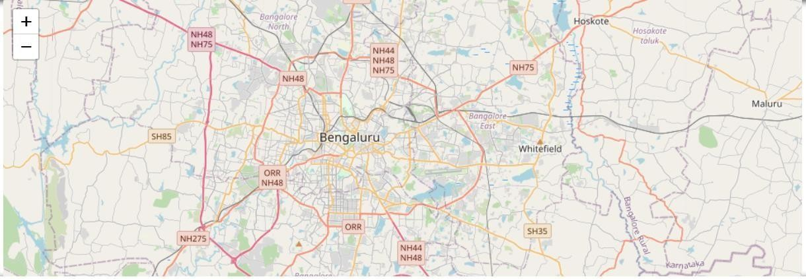

1. 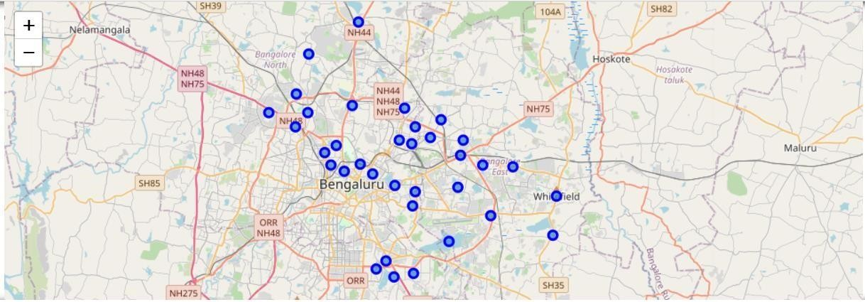Next, we mark the neighborhoods on the map. [Refer table on p.2]
2. Now we find the places according to our criteria. Our first

criteria is a ‘gym’. Here all those places are enlisted which have at least 1 gym in the vicinity of 2 km.

|  |  |  |  |
| --- | --- | --- | --- |
| **Venue Name** | **Venue Latitude** | **Venue Longitude** | **Venue Category** |
| Energy Fitness Centre | 12.989589 | 77.597131 | Gym / Fitness Center |
| The Leela Spa & Fitness Centre | 12.961124 | 77.648514 | Spa |
| The Tribe Cult Fitness | 12.980738 | 77.640515 | Gym / Fitness Center |
| Affinity Gym | 13.009358 | 77.579678 | Gym |

|  |  |  |  |
| --- | --- | --- | --- |
| **Venue Name** | **Venue Latitude** | **Venue Longitude** | **Venue Category** |
| Affinity Gym | 13.009358 | 77.579678 | Gym |
| Affinity Gym | 13.009358 | 77.579678 | Gym |
| Fitness First | 12.971153 | 77.607010 | Gym |
| The Tribe Cult Fitness | 12.980738 | 77.640515 | Gym / Fitness Center |
| Fitness One | 13.001221 | 77.577104 | Gym |
| Sobha Lakeview Clubhouse | 12.929097 | 77.672374 | Gym |
| Bangalore Games And Fitness Institute | 12.976395 | 77.673035 | Gym / Fitness Center |
| Central Park Clubhouse | 12.994270 | 77.729227 | Gym / Fitness Center |
| Gold's Gym | 12.994386 | 77.660744 | Gym |
| NCC Maple Heights Gym | 12.993809 | 77.683218 | Gym |
| ZELA | 12.942457 | 77.694914 | Gym |
| Golds Gym | 12.972217 | 77.750529 | Gym / Fitness Center |
| Bon Ami Gym | 13.021292 | 77.657489 | Gym |
| Cult | 13.026561 | 77.633782 | Gym / Fitness Center |
| Bon Ami Gym | 13.021292 | 77.657489 | Gym |

|  |  |  |  |
| --- | --- | --- | --- |
| Cubo Fitness | 13.021756 | 77.640016 | Gym |
| Cubo Fitness | 13.021756 | 77.640016 | Gym |
| 4S Fitness | 13.025407 | 77.629496 | Gym / Fitness Center |
| Godrej Woodsman Estate | 13.054715 | 77.595815 | Gym |
| international fitness centre | 13.034830 | 77.557855 | Gym |
| crunch fitness regime | 13.030998 | 77.570374 | Gym |
| Maverick Fitness | 13.035546 | 80.239628 | Gym / Fitness Center |
| SnapFitness | 13.077049 | 77.558323 | Gym |
| Snap Fitness Yelahanka | 13.098181 | 77.584642 | Gym |
| Galaxy Club - Brigade Gateway | 13.011772 | 77.556788 | Gym / Fitness Center |
| **Venue Name** | **Venue Latitude** | **Venue Longitude** | **Venue Category** |
| Core Fitness | 12.913980 | 77.609382 | Gym |
| Core Fitness | 12.913980 | 77.609382 | Gym |
| Snap Fitness | 12.911908 | 77.644173 | Gym |
| Gold's Gym | 12.933583 | 77.621559 | Gym |

1. Now we move to our next criteria that the place should have restaurant near by.

|  |  |  |  |
| --- | --- | --- | --- |
| **Venue Name** | **Venue Latitude** | **Venue Longitude** | **Venue Category** |
| Ujwal Bar & Restaurant | 12.992280 | 77.594473 | Indian Restaurant |
| Lavonne | 12.963909 | 77.638579 | Café |
| Krispy Kreme Doughnuts | 12.970094 | 77.640671 | Bakery |
| Asha Sweet Center | 12.999371 | 77.571322 | Snack Place |
| Suvarna Gate | 13.003102 | 76.099373 | Indian Restaurant |
| Asha Sweet Center | 12.999371 | 77.571322 | Snack Place |
| Asha Sweet Center | 12.999371 | 77.571322 | Snack Place |
| Samarkand | 12.980616 | 77.604668 | Afghan Restaurant |
| Yauatcha | 12.973318 | 77.620072 | Asian Restaurant |
| Masala Klub | 12.984993 | 77.585115 | Indian Restaurant |
| Cafe Coffee Day | 12.924097 | 77.670549 | Café |
| Kabab Souq | 12.972259 | 77.679608 | Indian Restaurant |
| Masala Chai | 12.992018 | 77.702983 | Café |
| Uttam Sagar | 13.011732 | 77.667882 | Indian Restaurant |
| BelgYum | 12.997362 | 77.696744 | Creperie |
| Bengaluru Steak House | 12.950549 | 77.698460 | Steakhouse |
| Domino's Pizza | 12.956000 | 77.741000 | Pizza Place |
| Herbs and Spices | 12.968145 | 77.750862 | Eastern European Restaurant |
| **Venue Name** | **Venue Latitude** | **Venue Longitude** | **Venue Category** |
| Al Amanah | 13.015631 | 77.639408 | Falafel Restaurant |
| Adyar Ananda Bhavan | 13.041035 | 77.624513 | Vegetarian / Vegan Restaurant |
| Rasta Cafe | 13.020604 | 77.643209 | Bistro |

|  |  |  |  |
| --- | --- | --- | --- |
| Thran | 13.021657 | 77.640438 | Korean Restaurant |
| Al Amanah | 13.015631 | 77.639408 | Falafel Restaurant |
| Connie's | 13.014932 | 77.633026 | Steakhouse |
| Uttam Sagar | 13.011732 | 77.667882 | Indian Restaurant |
| Huliyappa Donne Biryani | 13.026804 | 77.590756 | Indian Restaurant |
| Mezzaluna | 13.042339 | 77.554738 | Italian Restaurant |
| Thalassery Restaurant | 13.029953 | 77.562116 | Kerala Restaurant |
| Palette, Taj Vivanta | 13.029171 | 77.540681 | Restaurant |
| New Bombay Halwa House | 13.042786 | 80.233486 | Indian Restaurant |
| Domino's Pizza | 13.078761 | 77.559073 | Pizza Place |
| Cafe Coffee Day | 13.099390 | 77.588282 | Café |
| Chili's | 13.011297 | 77.555114 | Mexican Restaurant |
| Cafe Coffee Day | 12.916659 | 77.620249 | Café |
| Domino's Pizza | 12.824414 | 77.684356 | Pizza Place |
| Adyar Ananda Bhavan (A2B) | 12.916653 | 77.609745 | Vegetarian / Vegan Restaurant |
| Here & Now | 12.913618 | 77.638243 | Burger Joint |
| Chechi's Mess | 12.926053 | 77.617939 | Indian Restaurant |

1. Our third criteria was having a bus station within a walkable distance.

|  |  |  |  |  |
| --- | --- | --- | --- | --- |
| **Venue Name** | | **Venue Latitude** | **Venue Longitude** | **Venue Category** |
| Shivaji Nagar Bus Stand | | 12.983187 | 77.603106 | Bus Station |
| Doopanhalli bus stop | | 12.963907 | 77.641624 | Bus Station |
| HAL 2nd Stage 12th Main bus stop | | 12.970124 | 77.641193 | Bus Station |
| Hassan KSRTC Bus Stand | | 12.998097 | 76.104269 | Bus Station |
| Gayathri Vihar Bus Stop | | 13.013464 | 77.584205 | Bus Station |
| Shivaji Nagar Bus Stand | | 12.983187 | 77.603106 | Bus Station |
| HAL 2nd Stage 12th Main bus stop | | 12.970124 | 77.641193 | Bus Station |
| (VRL) Vijayanand Roadlines | | 12.980617 | 77.575596 | Bus Station |
| Bayanpalya bus stop | | 12.924704 | 77.671388 | Bus Station |
| Malleshpalaya Bus Stand | | 12.974652 | 77.670879 | Bus Station |
| Hoodi Bus Stop | | 12.992148 | 77.715785 | Bus Station |
| Tin Factory | | 12.996619 | 77.668989 | Bus Station |
| Mahadevpura | | 12.991452 | 77.687106 | Bus Station |
| Marathahalli Underbridge | | 12.956225 | 77.701178 | Bus Station |
| Ramagondanahalli Bus Stop | | 12.947888 | 77.742059 | Bus Station |
| Brookbond bus stop | | 12.964010 | 77.748653 | Bus Station |
| Banaswadi Ring Road Bus Stop | | 13.019483 | 77.654530 | Bus Station |
| Hennur Crossroad Bus Stop | | 13.028486 | 77.631370 | Bus Station |
| Banaswadi Ring Road Bus Stop |  | 13.019483 | 77.654530 | Bus Station |
| Babusapalya Bus Stop | | 13.022495 | 77.647457 | Bus Station |
| ITC Bus Stop | | 12.998523 | 77.625955 | Bus Station |

|  |  |  |  |
| --- | --- | --- | --- |
| Kasturi Nagar Bus Stop | 13.003558 | 77.663240 | Bus Station |
| Hebbal Bus Terminus | 13.040231 | 77.589654 | Bus Station |
| Gokula Bus stop | 13.039891 | 77.557428 | Bus Station |
| **Venue Name** | **Venue Latitude** | **Venue Longitude** | **Venue Category** |
| Mathikere ,Bengaluru | 13.033745 | 77.558318 | Bus Station |
| Peenya | 13.035414 | 77.519476 | Bus Station |
| C I T Nagar Bus Stop | 13.028381 | 80.230517 | Bus Station |
| Vidyaranyapura Bus Stand | 13.083066 | 77.557320 | Bus Station |
| Yeshwantpur Metro Station | 13.024709 | 77.547805 | Bus Station |
| Roopena Agrahara | 12.911401 | 77.626509 | Bus Station |
| KPN | 12.821757 | 77.686390 | Bus Station |
| Udupi Garden Bus stop | 12.916604 | 77.610206 | Bus Station |
| HSR-BIAS Bus Stop | 12.912765 | 77.638200 | Bus Station |
| SRS Travels | 12.925805 | 77.617363 | Bus Station |

1. Finally we need a multiplex theatre near by our location.

|  |  |  |  |
| --- | --- | --- | --- |
| **Venue Name** | **Venue Latitude** | **Venue Longitude** | **Venue Category** |
| Fun Cinemas | 12.988326 | 77.594769 | Multiplex |
| INOX Lido Mall | 12.966868 | 77.640919 | Multiplex |
| INOX Lido Mall | 12.966868 | 77.640919 | Multiplex |
| INOX | 12.991699 | 77.570569 | Multiplex |
| Cauvery Theatre | 13.002542 | 77.583405 | Movie Theater |
| INOX | 12.991699 | 77.570569 | Multiplex |
| Lavanya Theatre | 12.984622 | 77.614693 | Multiplex |
| Inox Lido Mall | 12.973078 | 77.621315 | Multiplex |
| INOX | 12.991699 | 77.570569 | Multiplex |
| PVR | 12.926328 | 77.675347 | Multiplex |
| Cinepolis | 12.989299 | 77.728127 | Movie Theater |
| **Venue Name** | **Venue Latitude** | **Venue Longitude** | **Venue Category** |
| Gopalan Cinemas | 12.993075 | 77.663948 | Multiplex |
| PVR Market City | 12.997531 | 77.695813 | Multiplex |
| Innovative Multiplex | 12.951922 | 77.698981 | Multiplex |
| INOX Forum Value Mall | 12.959807 | 77.747662 | Multiplex |
| PVR Cinemas Elements Mall | 13.045222 | 77.626789 | Multiplex |
| Cinépolis | 13.001441 | 77.632615 | Multiplex |
| Cinépolis | 13.001441 | 77.632615 | Multiplex |
| PVR Vaishnavi | 13.024152 | 77.548733 | Multiplex |
| Carnival Cinemas | 13.040407 | 77.518138 | Multiplex |
| Devi Multiplex | 13.033621 | 80.238647 | Multiplex |

|  |  |  |  |
| --- | --- | --- | --- |
| INOX Cinemas | 13.094407 | 77.595550 | Multiplex |
| PVR Vaishnavi | 13.024152 | 77.548733 | Multiplex |
| PVR Cinemas | 12.907622 | 77.601082 | Multiplex |
| PVR Cinemas | 12.934389 | 77.611184 | Multiplex |

1. Now we take intersection of all the latitudes and longitudes found in the four look ups that we performed.

The reason behind taking intersection of these sets is to shortlist only those locations which satisfy all the four look up criteria. A Venn Diagram shall make it a lot easier to understand.

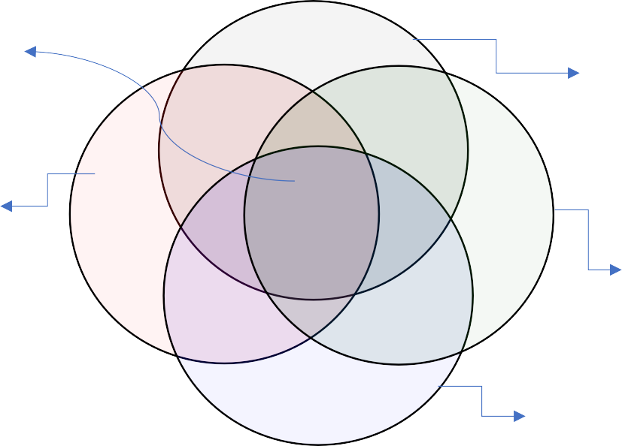

Places fulfilling all the 4 criteria

Gym

Multiplex

Bus Station

Restaurant

1. Now finally we put this result in a tabular format.

This list gives us the names along with the latitudes & longitudes of those

places.

This concludes our study.

|  |  |  |  |  |  |  |
| --- | --- | --- | --- | --- | --- | --- |
| **Name** | | **Latitude** | | | **Longitude** | |
| Cantonment area,Bangalore | | 12.993687 | | | 77.598000 | |
| Domlur,Bangalore | | 12.962467 | | | 77.638196 | |
| Indiranagar,Bangalore | | 12.973291 | | | 77.640467 | |
| Malleswaram,Bangalore | | 13.002735 | | | 77.570325 | |
| Sadashivanagar,Bangalore | 13.007708 | | | 77.579589 | | |
| Seshadripuram,Bangalore | | 12.993188 | | | 77.575342 | |
| Shivajinagar,Bangalore | | 12.986391 | | | 77.607542 | |
| Ulsoor,Bangalore | | 12.977879 | | | 77.624670 | |
| Vasanth Nagar,Bangalore | | 12.988721 | | | 77.585169 | |
| Bellandur,Bangalore | | | 12.935772 | |  | 77.666761 |
| Hoodi,Bangalore | | 12.991903 | | | 77.716201 | |
| Krishnarajapuram,Bangalore | | 13.000509 | | | 77.675394 | |
| Mahadevapura,Bangalore | 12.993498 | | | 77.692416 | | |
| Marathahalli,Bangalore | | 12.955257 | | | 77.698416 | |
| Whitefield,Bangalore | | 12.969637 | | | 77.749745 | |
| Banaswadi,Bangalore | | 13.014162 | | | 77.651854 | |
| HBR Layout,Bangalore | | 13.035870 | | | 77.632360 | |
| Kalyan Nagar,Bangalore | | | 13.022142 | |  | 77.640337 |
| Kammanahalli,Bangalore | | 13.009346 | | | 77.637709 | |
| Lingarajapuram,Bangalore | | 13.011768 | | | 77.627829 | |
| Mathikere,Bangalore | | 13.032888 | | | 77.557374 | |

|  |  |  |
| --- | --- | --- |
| R. T. Nagar,Bangalore | 13.029448 | 80.230906 |
| Yelahanka,Bangalore | 13.100698 | 77.596345 |
| **Name** | **Latitude** | **Longitude** |
| Yeshwanthpur,Bangalore | 13.021835 | 77.547686 |
| BTM Layout,Bangalore | 12.915177 | 77.610282 |
| HSR Layout,Bangalore | 12.911623 | 77.638862 |
| Madiwala,Bangalore | 12.921227 | 77.617951 |

# Conclusion:

1. Using geospatial database like ‘Foursquare’ and deploying that data through the python coding is an unbelievably efficient way to find places of our interests; whatever hard or complex criteria might be considered.
2. The geospatial database coupled with as strong language as python opens up many exciting windows for any creative person to come up with different solutions for dayto-day problems.